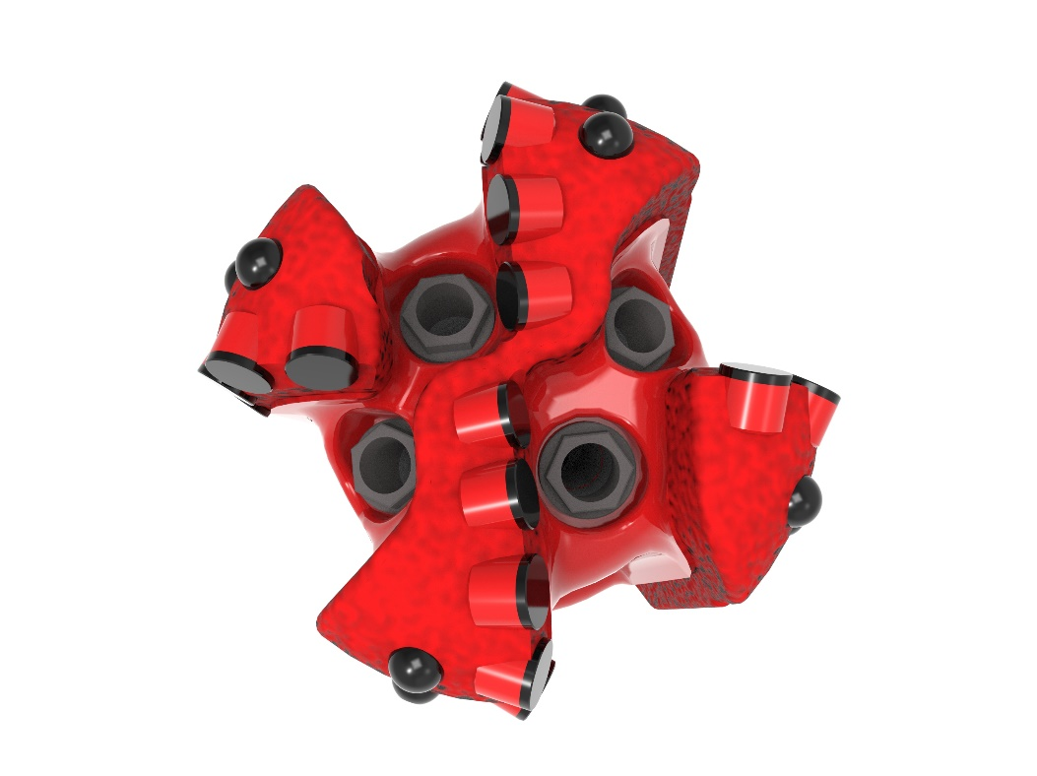
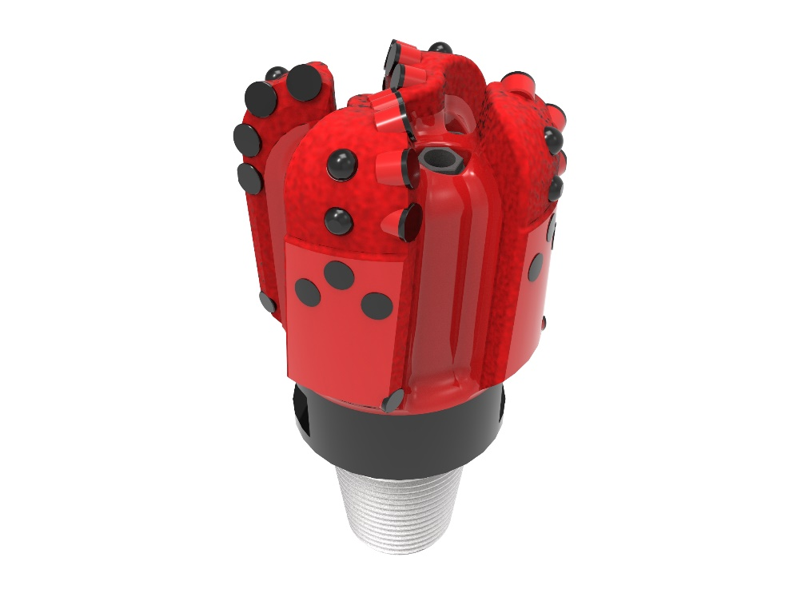

Drill Bit Specifications:
Cutter Size (Primary, Sec) | 5/8”,1/2”
Cutter Count (Total,Gage,Back Ream) | 21, 4, 4
Blade Count | 4
Gage Length (Inches) | 3.00
Nozzle Count (Primary, Sec.) | 4
Nozzle Series (Primary, Sec.) | 60
JSA (Sq. Inches) | 7.574
Max. TFA (Sq. Inches) | 1.48
Operating Parameters:
Max. Weight on Bit (1,000 Lbs.) | 28
Make-up Torque (ft/lbs) | 7,611
Nominal Dimensions:
Overall Length (Inches) | 11.49
Make Up Length (Inches) | 7.74
Bit Breaker | SKB-21012
Connection | Ø3-1/2" API Reg.
Approx. Weight (Lbs.) | 45

Tailor-Made Features:

- Premium grade cutters maximize ROP and Life

- Nozzle configuration and large open face volume optimize blade cleaning and cuttings removal

416-SR(K)(BR) Nomenclature Explained:

• | 4 | = | Number of Blades
• | 16 | = | Primary Cutter Size (16mm)
• | SR+ | = | Single Row of Cutters
• | K | = | Bullets
• | BR | = | Back Reaming Cutters


